|  |  |  |
| --- | --- | --- |
| Nama | : | Hanif Cahyo Prasetyo |
| NIM | : | A11.2022.14075 |
| Mata Kuliah | : | Pemprograman Berbasis Web |

1.Git Bash

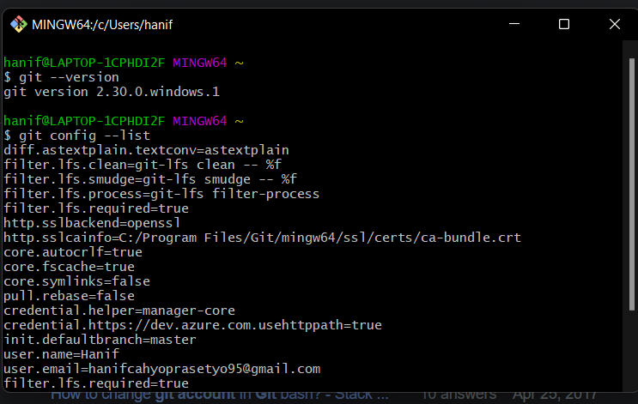

2. Github Desktop

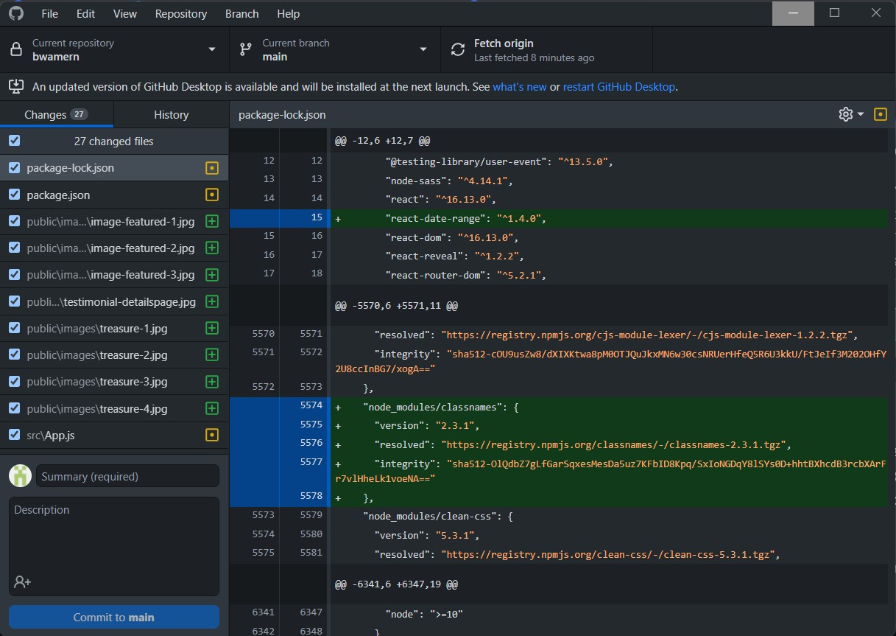

3. Github Profile

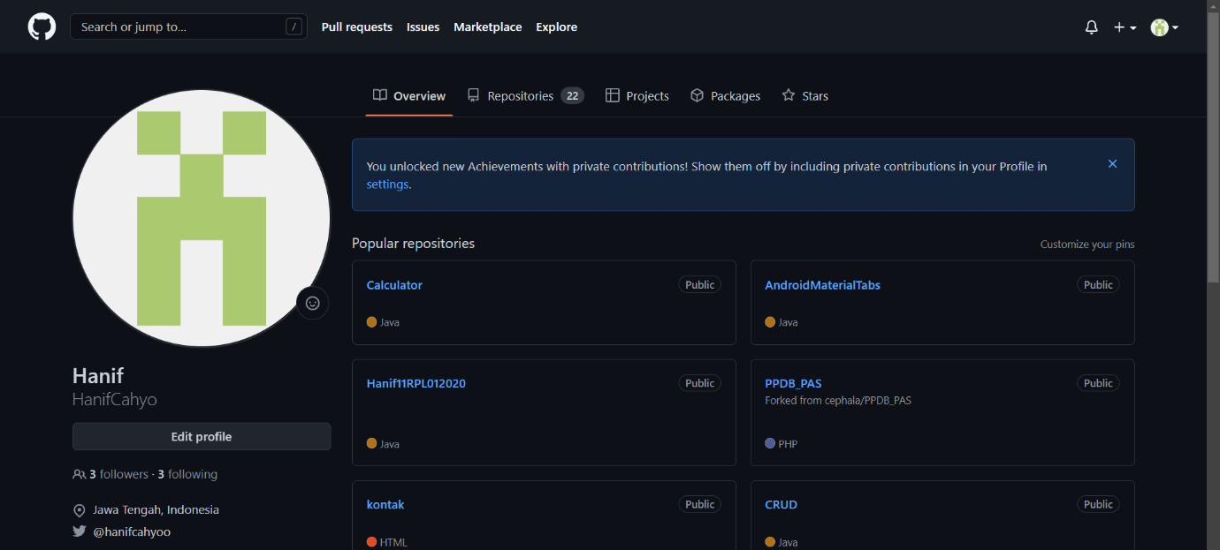

4. XAMPP Control Panel – Web server Apache, MySQL

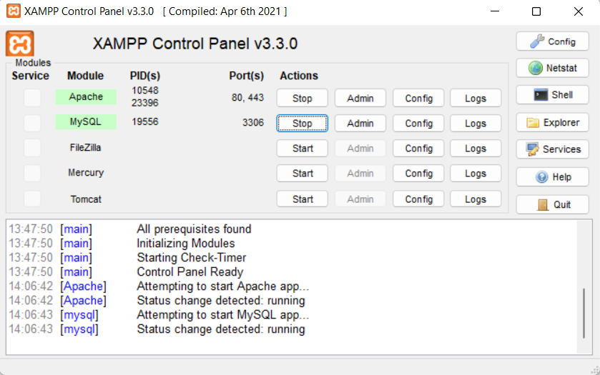

5. Localhost

